PROJECT TITLE
PROJECT REPORT

Submitted in the partial fulfilment of the requirements for award of the

6 Months Online Certificate Course

in

Data Science with Python Programming

By

KODURU SESHA SAI SREYA

(Ht. No. 2206DSP183)



SCHOOL OF CONTINUING AND DISTANCE EDUCATION
JAWAHARLAL NEHRU TECHNOLOGICAL UNIVERSITY HYDERABAD

Kukatpally, Hyderabad-500085, Telangana State, India.
MARCH 2023

5
6
OBJECTIVES
METHODOLOGY
7
ALGORITHM
8
9
10
11
IMPLEMENTATION
RESULT AND ANALYSIS
CONCLUSION AND FUTURE SCOPE
REFERENCES
8
8
9
10
11
12
12

TABLE OF CONTENTS
1
2
3
4
INTRODUCTION
LITERATURE SURVEY
PROBLEM STATEMENT
3
5
6
7

Chapt er No | Chapter Name | Page Number
 | ABSTRACT

Netflix data analysis
(a project on machine learning using python)

- Name: Koduru Sesha Sai Sreya
- Hall ticket No: 2206DSP183
- Registration No: 223182
- Area of Project: Machine Learning
- E-Mail I’d: sreyapandu@gmail.com
- Project Title: Netflix data analysis (a project on machine learning using python
- Software used: Jupiter Notebook, visual studio code and Python
- Data sets: Netflix data analytics task consists of TV shows and movies streamed on Netflix as of 2019. The dataset is provided by Flixable which is an engine of third-party research available on Netflix

NETFLIX DATA ANALYSIS WITH PYTHON
A PROJECT ON MACHINE LEARNING USING PYTHON

Netflix is one of the largest providers of online streaming services. It collects a vast amount of data because it has a huge subscriber base. In this project, we can analyse a lot of data and models from Netflix because this platform has consistently focused on changing business needs by shifting its business model from on-demand DVD movie rental and now focusing a lot on the production of its original shows and can look at some very important models of Netflix data to understand what’s best for their business. Some of the most important tasks that we can analyse from Netflix data are:
- understand what content is available

understand the similarities between the content
- understand the network between actors and directors

what exactly Netflix is focusing on
- and sentiment analysis of content available on Netflix.

The dataset I use for the Netflix data analytics task consists of TV shows and movies streamed on Netflix as of 2019. The dataset is provided by Flixable which is an engine of third-party research available on Netflix.


K. SESHA SAI SREYA
223182
HT.NO: 2206DSP183

INTRODUCTION

Netflix is one of the largest providers of online streaming services. It collects a huge amount of data because it has a very large subscriber base.
We can analyse a lot of data and models from Netflix because this platform has consistently focused on changing business needs by shifting its business model from on-demand DVD movie rental and now focusing a lot about the production of their original shows.

With over 203.67 million subscribers worldwide, Netflix has reigned as the no.1 Over-the-Top (OTT) streaming content platform since its launch in 2007. The secret to Netflix’s success is Data and analytics.
Using advanced data and analytics, Netflix can:

- Provide users with personalized movie and TV show recommendations
- Predict the popularity of original content to before it greenlights it (or not)
- Personalize marketing content such as trailers and thumbnail images
- Optimize production planning
- And, of course, enhance general technical and business decision making

Literature Survey

The term “Data Analysis” is known to be rooted in the statistics space, which itself is known to have a long history. With the help of the statistical development techniques, we can derive interesting outcomes. The advancement of rapid technological implications in the world led to a consequent advent of Big Data; we are constantly being faced with enormous amounts of raw data which is subject to future enhancements based on the required parameters and criteria by an entity. Starting with the collection of data, the most common and subsequent step is to perform the analysis of it. Data analysis is hence known to be a scientific process solely focused on the data as its subject. It begins with retrieving data from various external-cum-internal sources and then performing intrinsic analysis with the data in order to discover and obtain beneficial information catering the needs of an entity. For example, the analysis of population growth by district can help governments determine the number of hospitals that would be needed in a given area. When collecting the optimal data for analysis it must hold the minimum viability in terms of features and attributes suitable for our analysis. This can be represented in terms of bodily and health-oriented features like Health Status, Age, Male: Female Ratio, BMI etc., will provide much more issue specific insights over the population. It can enable a person to visually represent these features as per the requirements.
Fundamentally, there are two primary methods for data analysis –
based on the nature and characteristic of data - qualitative data analysis and quantitative data analysis techniques. These data analysis techniques have the scope to be utilized independently or in combination with other methods in order to gain access to some of the best business and intelligence-oriented insights for making better decisions over the already present data.

Problem Statement

With the advent of technology, the need for consumption of data has increased tremendously. Every single activity of our life has become interlinked with data. As the famous British Mathematician – Clive Humby – once said,

“Data is the new oil.”
As interesting as it may sound, the fact that there is a constant need for intelligent solutions – with data as inputs – cannot be neglected. Due to these changes, we have witnessed a paradigm shifts in almost every single field around the world. One such field is the entertainment industry that had a rapid transposition as the industry soon began to adopt virtual methods for releasing its content. The Over-The-Top (OTT) as a means to provide and deliver content has gained huge prominence around the world. One of the key players in the game being Netflix, has changed the way people subject themselves to entertainment. The from-home-all-in-one package type subscription services that these OTT platforms has to offer had customers glued to them quite literally. All these behavioural information about large base of customers is essentially a valuable data. Thus, this project focuses on
deriving crucial insights from the publicly available Netflix dataset. We have
also made use of Geographical Data Set and Netflix Title Reviews Data Set.

Objectives
In this project, we can have a look at some very important models of Netflix data to understand what’s best for their business. Some of the most important tasks that we can analyse from Netflix data are:
- understand what content is available
- understand the similarities between the content
- understand the network between actors and directors
- what exactly Netflix is focusing on
- and sentiment analysis of content available on Netflix.

Methodology

- Requirements Gathering :
The data is the necessary requirement for providing inputs to any type of analysis. It can be based on the requirements and parameters based on the user. This data can be either numerical or categorical. The purpose and scope can range from supervised to unsupervised learning.

- Data Collection :
The required data can be collected from a wide range of sources. It can be structured based on the criteria provided by analysts to custodians of a particular data set. The data can be man-made or in the form of technological output over utility (Sensor system tracking) and many other implications.

- Data Processing & Cleaning :
The data when purported for utilization must be processed on the level where the needs for analysis are satisfied. This includes placing data in the form of rows and columns that are human-understandable in nature. Further, it must be cleaned for getting rid of any redundant data, or minimalize the presence of anomalies prior to the deployment of the data for analysis.

- Conclusion:

Summarizing the results and drawing conclusions about the effectiveness of the proposed method.

Algorithm
Netflix was one of the early adapters of Bigdata Analytics in the year 2006 Netflix came up with a challenge that would award $1 Million to anyone who would improve their existing recommendation system called Cinematch by 10% [4]. The challenge was to develop and algorithm to predict the subscriber movie preference based on the older data. Netflix provided the dataset which contains about 100 million ratings provided by 480 thousand users for 17 thousand movies, Ratings were in the form like user, movie name, date of rating and rating provided by the user. The competition was carried over years and in the year 2008 the prize was awarded to BellKor's Pragmatic Chaos team which consisted of Mathematician, data scientist and engineers from different counties and from different industries and research institute including AT&T, Yahoo & Commendo Research & Consulting GmbH [5].This competition was a grand success many teams that participated in this competition has provided similar solution to other companies like ecommerce. However, the second competition which was announced by Netflix in the year 2010 had to be cancelled due to privacy issue lawsuit against the Netflix for the dataset that has been used in the competition. Netflix uses Data Science and Bigdata Analytics in their recommendation systems. In late 1990’s, the term recommender system was introduced for the first time in literature of information system [6]. The interest in recommendation system remains as it is widely applicable to solve the practical problems of many companies. Many companies like amazon, Microsoft etc. have a commercial recommendation system.

Implementation
Once our required datasets are generated – with inculcated properties like optimal,
structured and human-understandable data format – we can now proceed further for an in-depth analysis of it. To begin with, We have applied a variety of techniques to gain maximum insights from our data set.
To begin the task of analyzing Netflix data, I’ll start by looking at distribution of content ratings on Netflix:
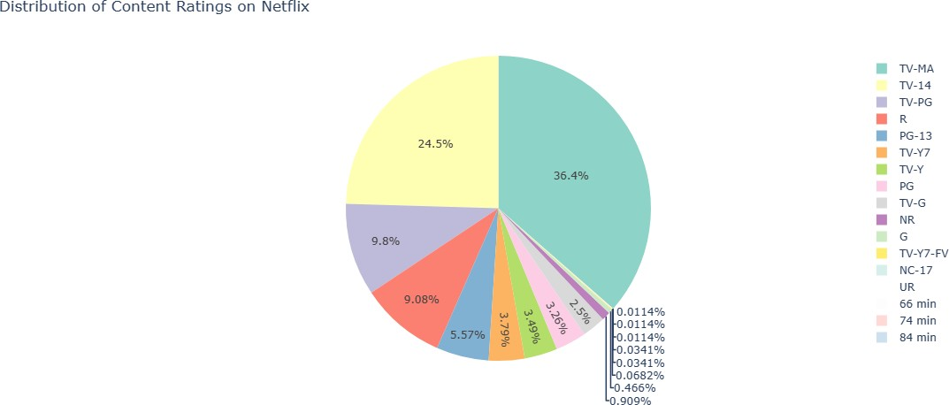

Analyse from this data is the trend of production over the years on Netflix:

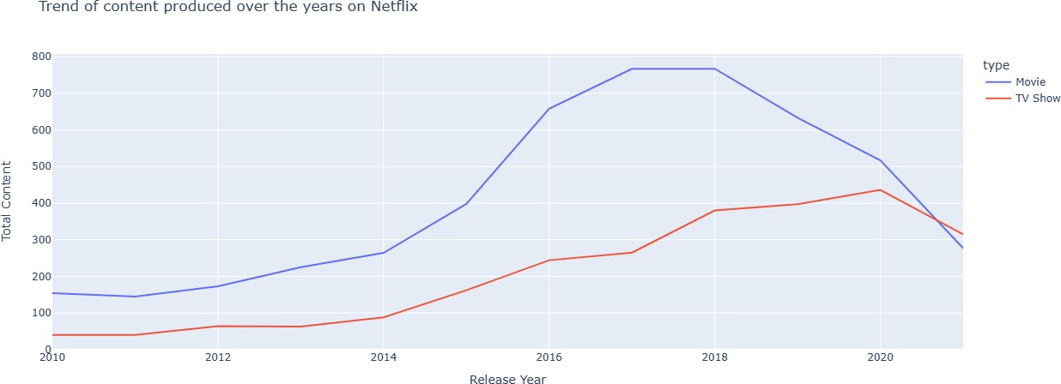

Sentiment of content on Netflix:

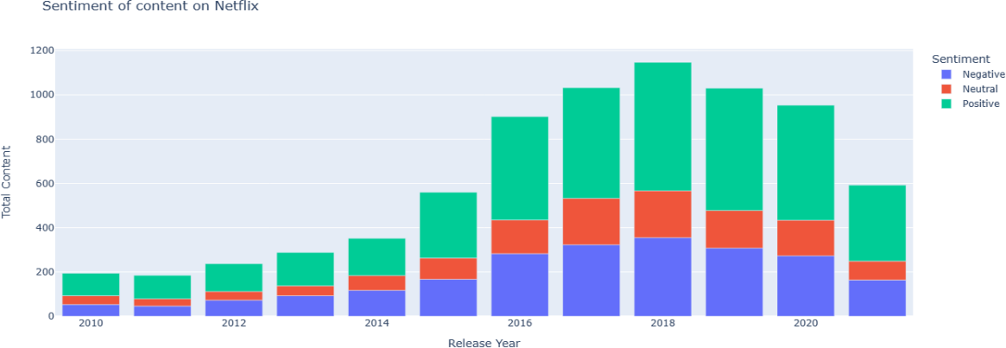

Results & Analysis
The Netflix data we have garnered some crucial insights for other useful purposes. The following are summarized points:
- We have successfully cleaned the redundant records by removing them, and filtered the Data Set by discarding unused features
- We developed a correlation amongst the utility features and established a guidance for our analysis
- Built a plotting for size of Series & Movies in the dataset

Derived the top 5 directors top 5 actors, on this platform.
- Built a Sentiment Analysis Model by fitting the Series/Movie Reviews dataset, which obtains the result by making use of the summary column in the Netflix dataset.
Using the above methods and techniques we derived maximum results that are suitable for making better business decisions.

Conclusion & Future Scope

Data Analysis is a fundamental step to address the various needs of a client in any professional spectrum. The varied range of insights that can be derived from a data is itself primarily valuable in nature as there are multiple businesses that are actively looking for futuristic, predictive and descriptive insights from the already present raw data generated by them. It helps the organizations to gain access to numerous concealed patterns, information and bits of knowledge after the analysis had been performed. The analysis that we have just performed using the Netflix data not only provides us with incentives to take smart and intelligent business decisions, but also contribute to the overall growth of the firm. These insights maintain a clear sight and perspective for various stakeholders and help in targeting a positive vision for the future. The future scope of Data Analysis is bound to remain intact as long as businesses require Data Science in their everyday applicable decision-making processes. Also, there is a great scale of possibilities when it comes to developing unique interactive solutions and methods that are confined to make data exploration much more intriguing in nature. These constant advancements have stabilized a promising direction for data analysis as a systemic study that is going to stay as long as there is the crunch for data in any viable field of study in the real-world.

- Data analysis - Wikipedia
References

- Represent your Geospatial Data using Folium | by Slavvy Coelho | Towards Data Science
- https://www.researchgate.net/publication/354719521_Exploratory_and_Sentiment_Ana lysis_of_Netflix_Data
- https://www.aidataanalytics.network/data-science-ai/articles/data-science-at-netflix- how-advanced-data-analytics-helped-netflix-generate-billions

